**Activity 1 – Understanding Myself**

1. Check your IQ - <https://www.test-guide.com/iq/free-iq-tests/free-iq-test.html>
2. Check your EQ - <https://globalleadershipfoundation.com/geit/eitest.html>
3. Check your Personality type - <http://www.humanmetrics.com/cgi-win/jtypes2.asp>

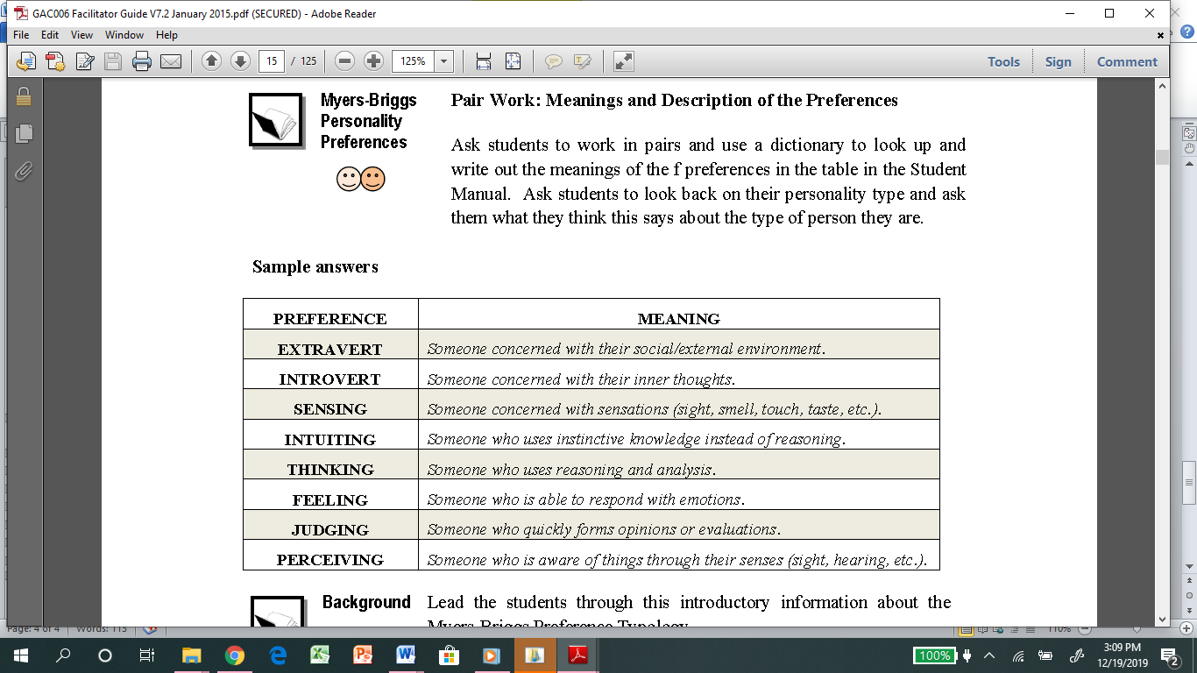

1. Rank your values

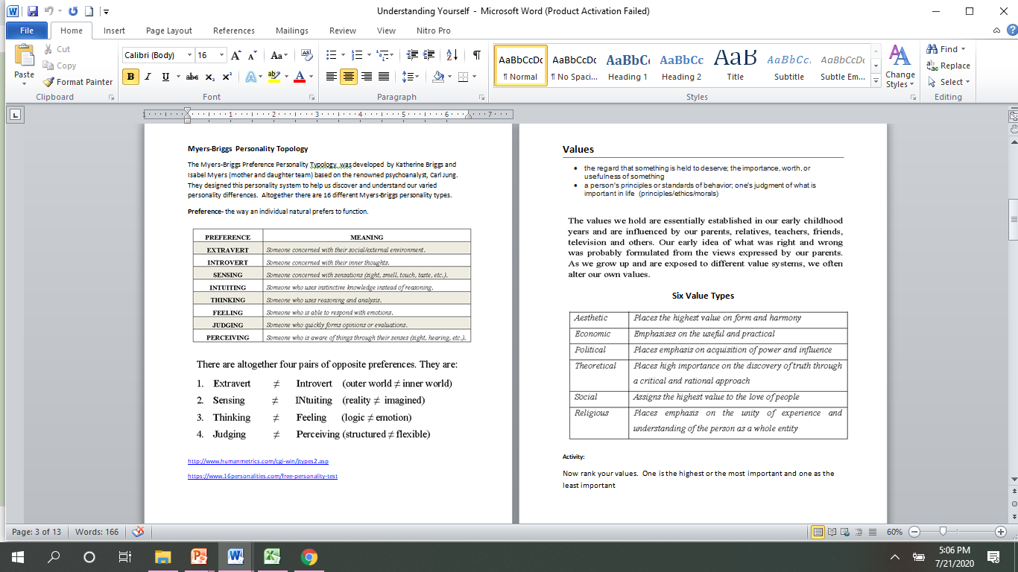

3. What stops you from achieving your goals? What can help you overcome the challenges of achieving your goals?

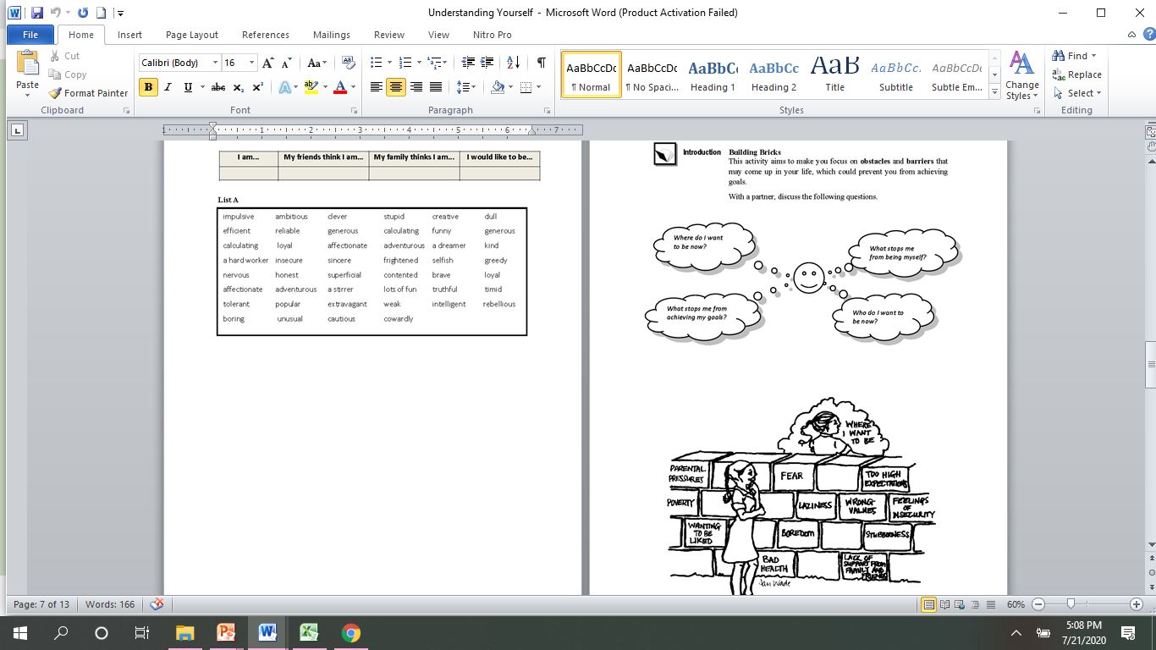

1. Send the results to aye.zaragoza0101@gmail.com

|  |  |  |
| --- | --- | --- |
| Name: | | |
| Results | | |
| IQ | 140 | |
| EQ |  | |
| Personality Type |  | |
| Values | 1 as the highest and 5 as the lowest | |
| 3 | Aesthetic |
| 2 | Economic |
| 4 | Political |
| 1 | Theoretical |
| 3 | Social |
| 3 | Religious |

|  |  |
| --- | --- |
| **What stops me from achieving my goals?** | **How can I overcome it?** |
| The lack of knowledges | Directly asking instructors and consultants. |
| The tired feeling after thinking much tasks at same time | Take a break for a short-term day. |
| The requirement beyond ability. | Trying to find out the research resources that related to small details and solve it slowly. |
| The shortage of reliable sources | Try to get closer to acquaintances and colleagues to increase the number of sources |